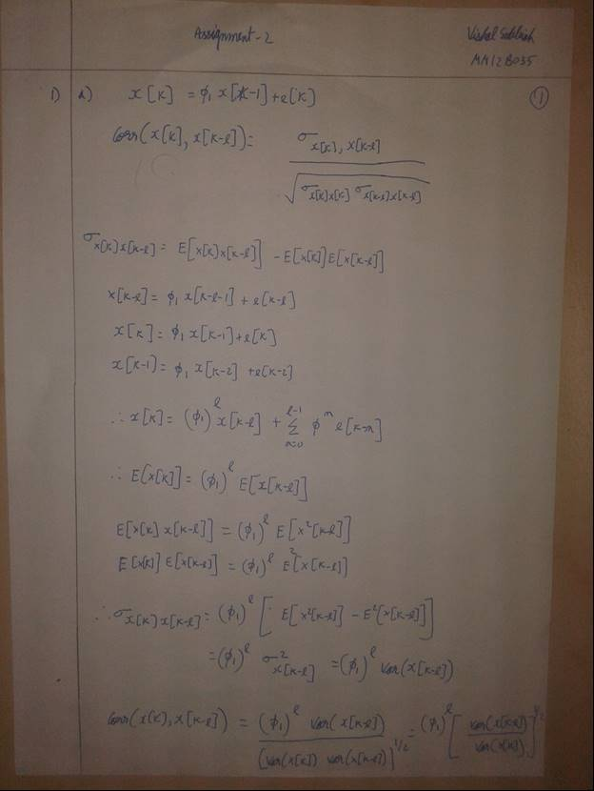

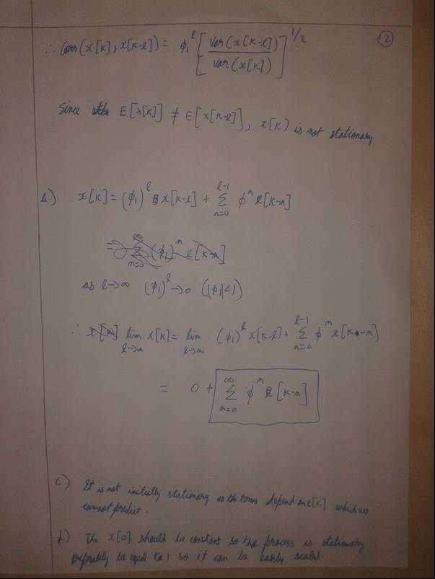

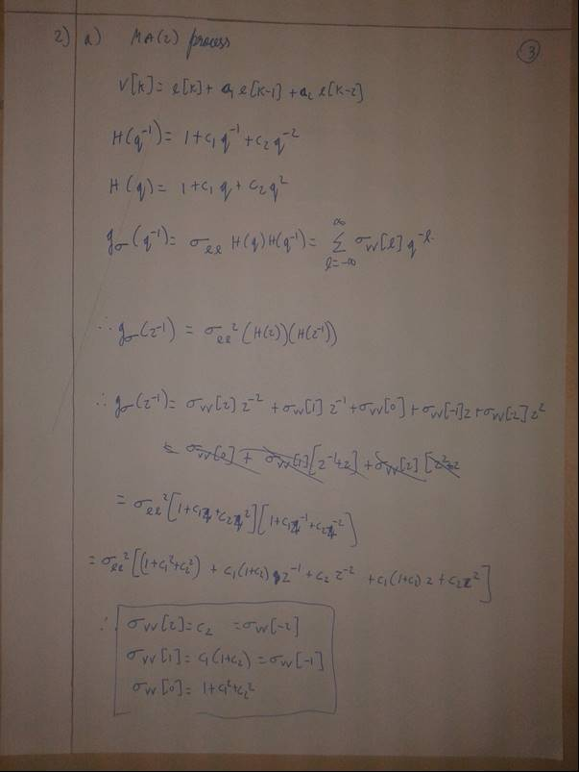

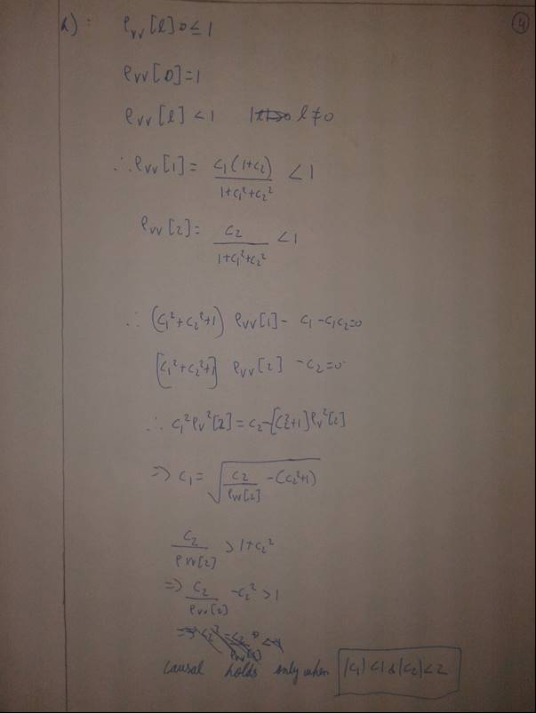

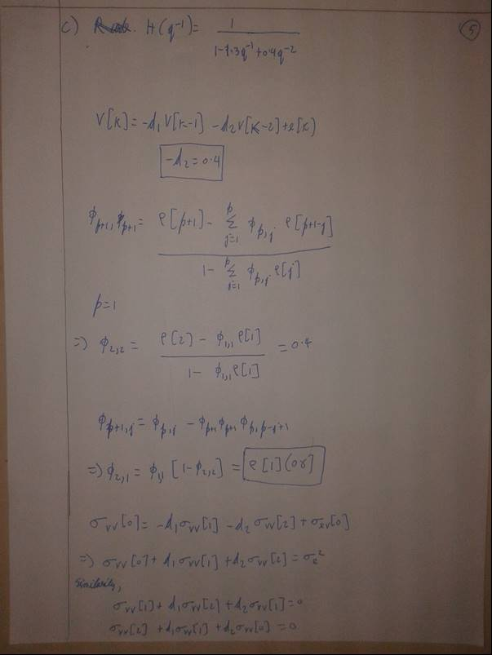

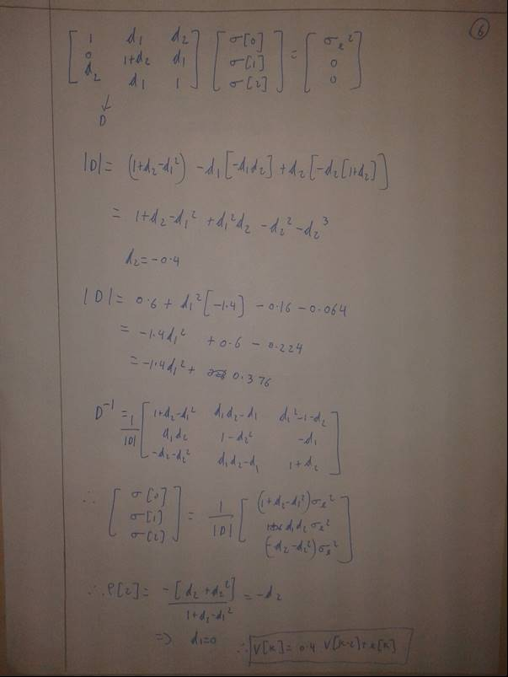

2) acf_v <- ARMAacf(ar=c(0,0.4),lag.max=30)

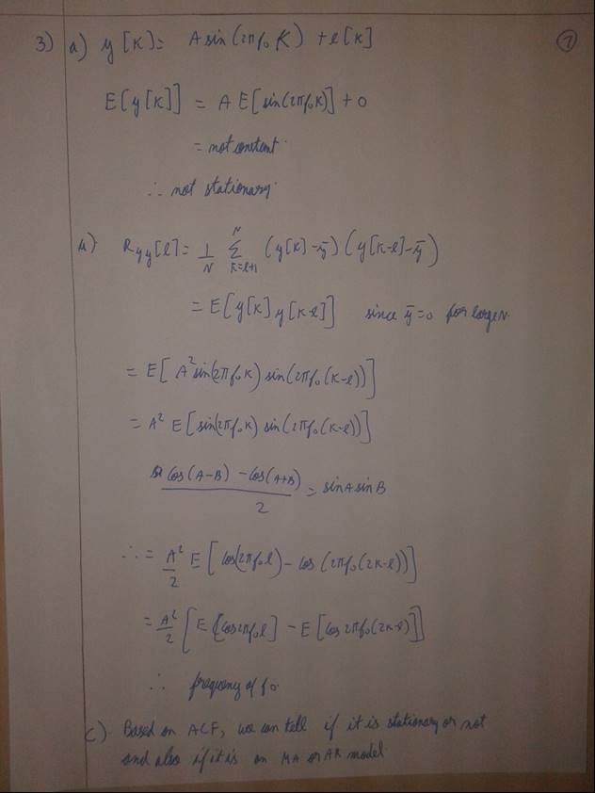

3d) k=c(1:1000)

t=sin(2*pi*0.2*k)

sigt=var(t)

sige=sigt/10

e=rnorm(1000,0,sqrt(sige))

y=sin(2*pi*0.2*k)+e

acf(y,lag.max =NULL,type="covariance",plot=TRUE)

# in the plot we can see that the graph repeats at lags of 5 which implies the frequency is 0.2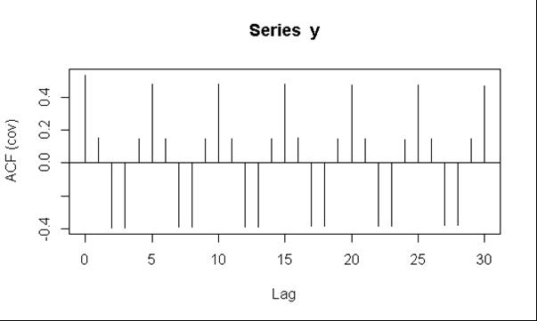

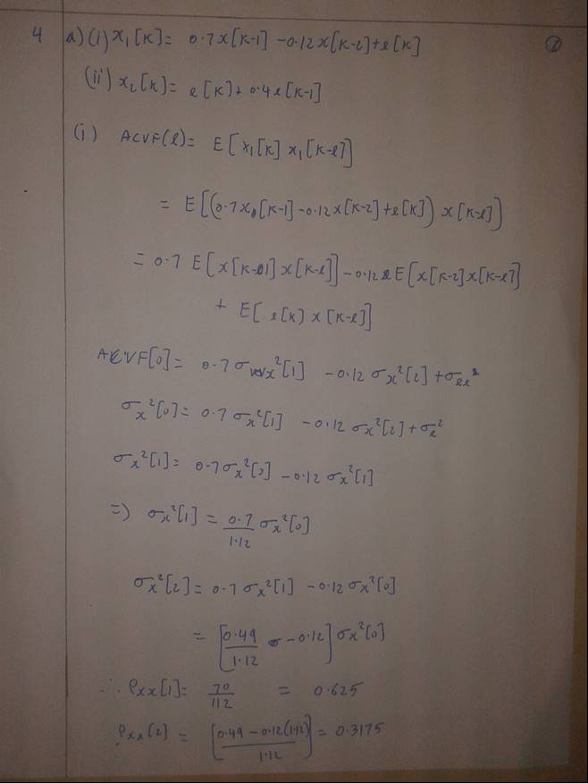

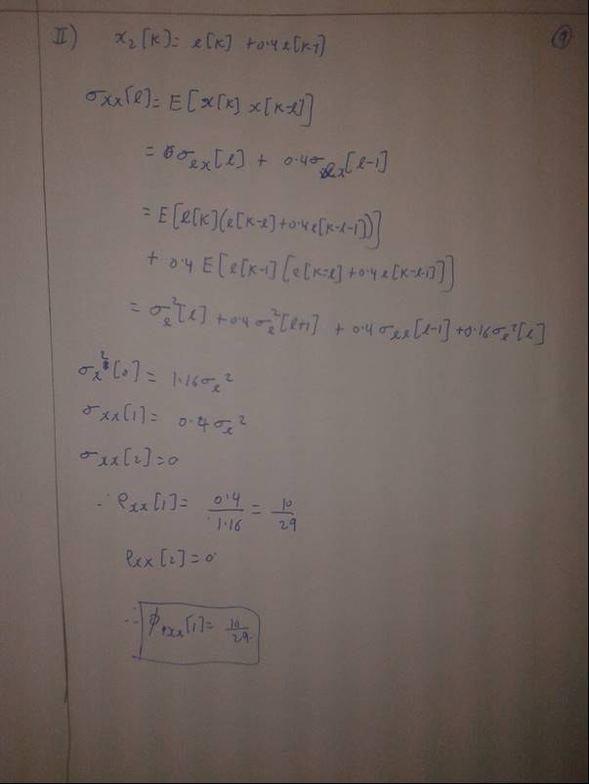

4a)

acf_x1 <- ARMAacf(ar=c(0.7,-0.12),lag.max=4,pacf= TRUE)

acf_x2 <- ARMAacf(ma=c(0.4),lag.max=4,pacf = TRUE)

pacf_x1_1=acf_x1[1]# pacf at lag 1 for x1

pacf_x1_2=acf_x1[2]# pacf at lag 2 for x1

pacf_x2_1=acf_x2[1]# pacf at lag 1 for x2

pacf_x2_2=acf_x2[2]# pacf at lag 2 for x2

4b)

SMI=EuStockMarkets[,3]

mag=quakes[,4]

not=nottem

k=c(1:1000)

e=rnorm(1000,0,1)

x=0.01*k + e

#time series

plot(SMI)

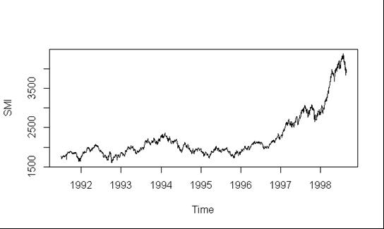

plot(mag)

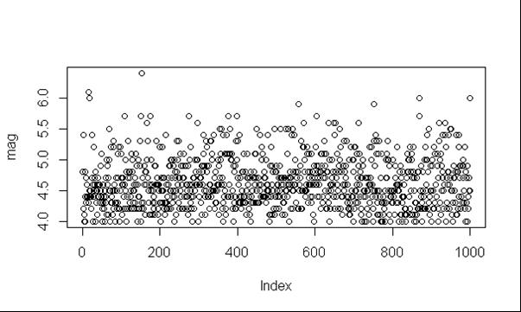

plot(not)

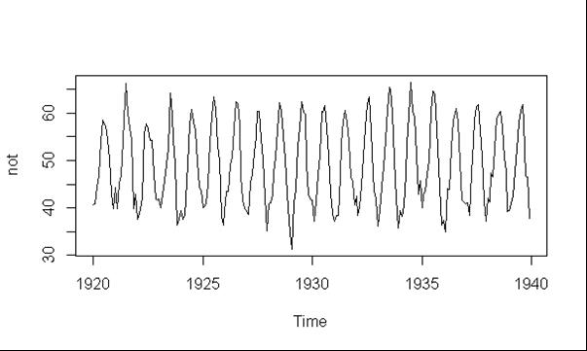

plot(k,x)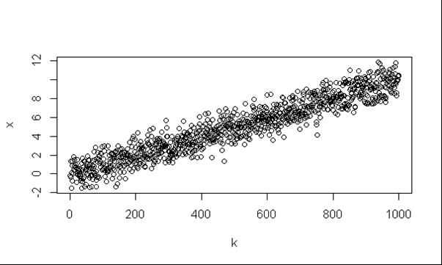

#ACF

acf(SMI,lag.max =NULL,type="correlation",plot=TRUE)

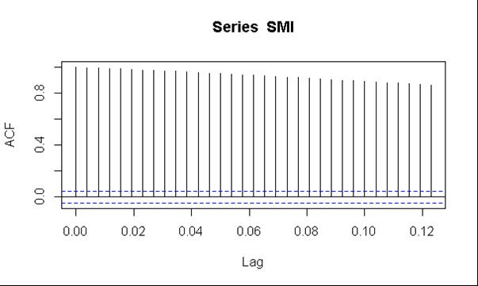

acf(mag,lag.max =NULL,type="correlation",plot=TRUE)

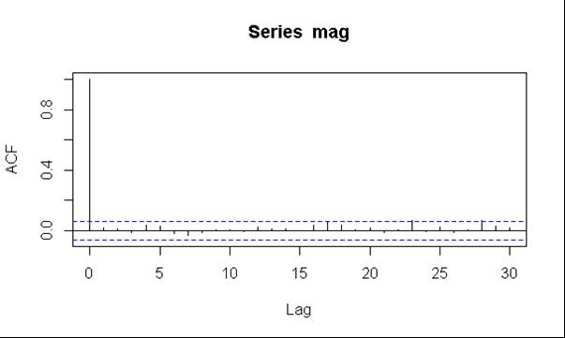

acf(not,lag.max =NULL,type="correlation",plot=TRUE)

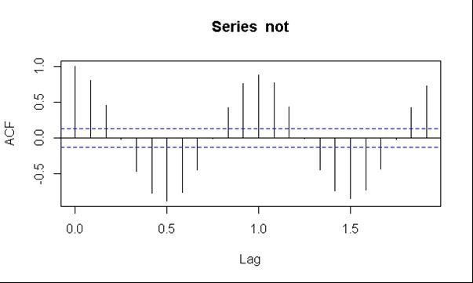

acf(x,lag.max =NULL,type="correlation",plot=TRUE)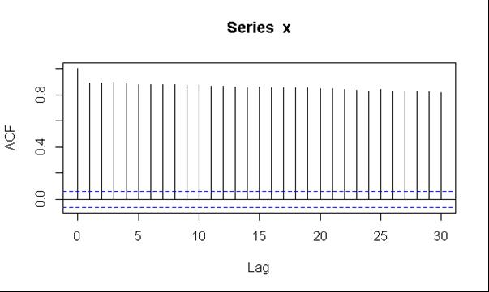

#PACF

pacf(SMI,lag.max =NULL,plot=TRUE)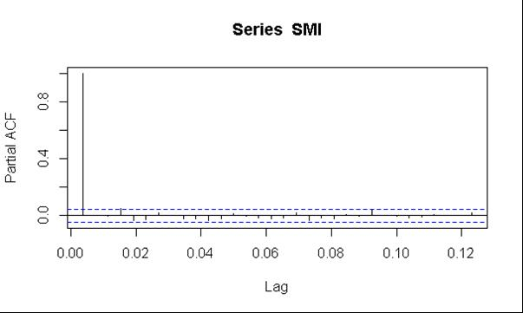

pacf(mag,lag.max =NULL,plot=TRUE)

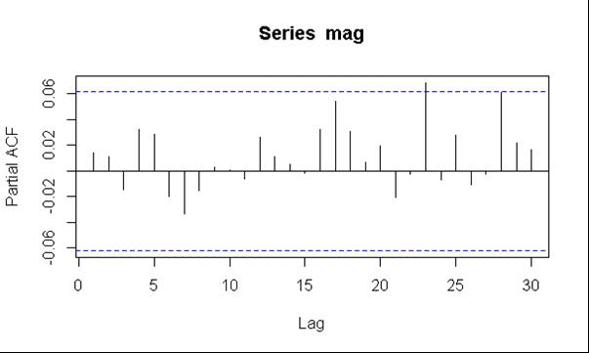

pacf(not,lag.max =NULL,plot=TRUE)

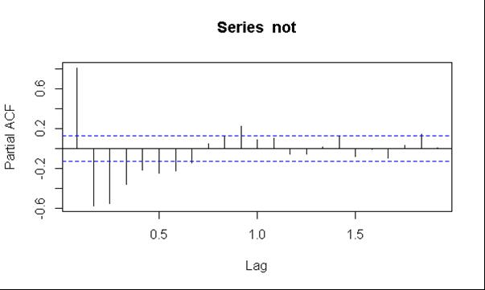

pacf(x,lag.max =NULL,plot=TRUE)

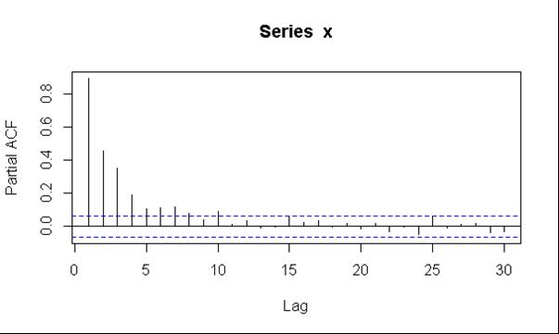

|  |  |  |
| --- | --- | --- |
|  | Stationary | Periodicity |
| SMI | Yes (AR model) | - |
| Quakes(mag) | Yes(MA model) | - |
| nottem | No | Yes(every 5 lags) |
| x | Yes(AR Model) | - |

5)

e=rnorm(1000,0,1)

t=acf(e,lag.max =NULL,type="correlation",plot=TRUE)

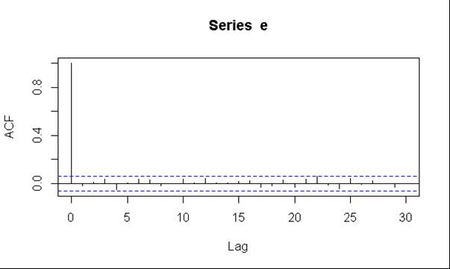

y=t$acf

z=acf(y,lag.max =20,type="correlation",plot=TRUE)

